Western redcedar trailside status monitoring
Protocol for Fidalgo Forest Stewards

Background

There is a perception that Western redcedar (Thuja plicata) are being stressed and dying at an increased rate in the ACFL compared to what has been observed in previous years and decades. These anecdotal observations are now being measured by forest composition citizen science studies by Dave Peterson and the volunteer Fidalgo Forest Stewards (FFS).
FFS volunteers have expressed interest in expanded observation studies specific to the Western redcedar, to be carried out once per year starting in July of 2019 and ongoing throughout the coming years.

This protocol is designed to guide our study efforts to provide useful data using controlled and repeatable observation and documentation methods.

Location:
The following trail sections have been identified as being spatially diverse across the spectrum of the ACFL, and having a presence of cedars to monitor. They involve a spectrum of wet and dry habitats, north and south exposures, a high and low density of cedars, and other variabilities.

The following trails or trail sections will be monitored dependent on volunteers available:

Trail | Length | Exposure | Moisture | Contour | Travel | Trail Section
123 | 0.36 | South | Moist |  | North | all
108 | 0.30 | E | moist | medium | North | from 10 to bridge
124 | 0.51 | NW | mixed | sloped | West | all
121 | 0.40 | South |  | medium | North | all
224 | 0.22 | flat | lowland | flat | North | all
210 | 0.70 | E to NW | mixed | sloped | N then SW | from 212 to 243 intersections
23 | 0.25 | NW |  | sloped | North | all
201 | 0.60 | N to flat | dry | medium | South | stop at plot study area
313 | 0.35 | SW | dry | sloped | South | all
304 | 0.30 | flat | moist | flat | East | from 302 to Heart Lake Road
309 | 0.20 | North | dry | sloped | South | all

The western redcedars along these trails will be surveyed for the density of foliage, color of the foliage, and height of the tree. Each trail survey should examine roughly 100 trees. This number is chosen to limit the duration of the survey on those trails that have high cedar counts. This is not a hard number and if the survey team choses to include a few extra trees in the survey, that is their choice.

Method:

Trails will be monitored once a year between June and July. Ideally, there will be at least two samplers, one to record data and one to measure distances and be a spotter.

After being assigned to a trail, volunteers will then hike these trails or portions of trails with a range finding device. On the data sheet (see attachment 1), survey teams will record the day, the time of day, the trail being studied, and the trail section. The Anacortes Forest Lands trail maps (available for download on the City of Anacortes website or for sale at the visitor center & Watermark Books) show the trails listed above and the end points/finish points of the trails.

Trails will always be walked in the same direction to keep the starting point identical.
Volunteers will survey each Western redcedar tree within five (5) meters on either side of the center of their assigned trail that are at least about two meters in height. The survey team will document each tree by first documenting which side of the trail the tree is on. Then record the distance to the nearest point of trunk from the center of trail (measure to one-tenth of a meter). As consistently as possible, measure the distance to the trunk at about chest to eye level on the trunk. Then note the approximate tree height as being 2 to 10 meters, 10 to 20 meters, or above 20 meters. The final measurements will be the qualitative health of the tree, based on leaf density and color. These observations are noted for each third of the tree (top, middle, and bottom thirds). These measurements are subjective, but by being consistent with the training given, the results will be reasonably accurate and valuable over time. Make notes in the comments section to help your team and future volunteers recognize specific trees on the survey list by noting tree anomalies (crooked trunk, group of 4 small trees, dead top, etc) and being careful to stand in the middle of the trail and holding the rangefinder against your chest. An accurate tree distance reading is very helpful in locating the same tree on future surveys.

Recent soil moisture studies have indicated that small trees, especially seedlings may not have significant access to moisture due to the recent string of prolonged droughts in the spring, summer, and fall. These drought periods may result in unusually high die off in the young trees (trees under 2m). The survey includes the counting of trees under 2m. Unlike the characterization of the larger trees, the trees under 2m will only be counted and not characterized. Count the total number of under 2m trees (do not identify individuals) found between the last tree above 2m and the next tree noting whether on left or right side of the trail, see Attachment 1.

All studies will be coordinated with the project lead for the western redcedar projects for trail assignment to avoid overlap with other volunteer teams, secure equipment, and allow for follow up as necessary. All forms are to be submitted in a timely manner to the project lead who will verify the accuracy and completeness of the survey. It is preferable that the team’s data is transferred to the Excel version of the data sheet prior to submittal, which will facilitate delivery and be very helpful for downstream data analysis. If the team is unable to transcribe the data to an Excel version of the data sheet, they should make sure the field record is clear and legible and then forward the hard copy to the project lead, who will make arrangements to transcribe the data.

Illustrations of Western Redcedar Health Characteristics

Leaf Density:
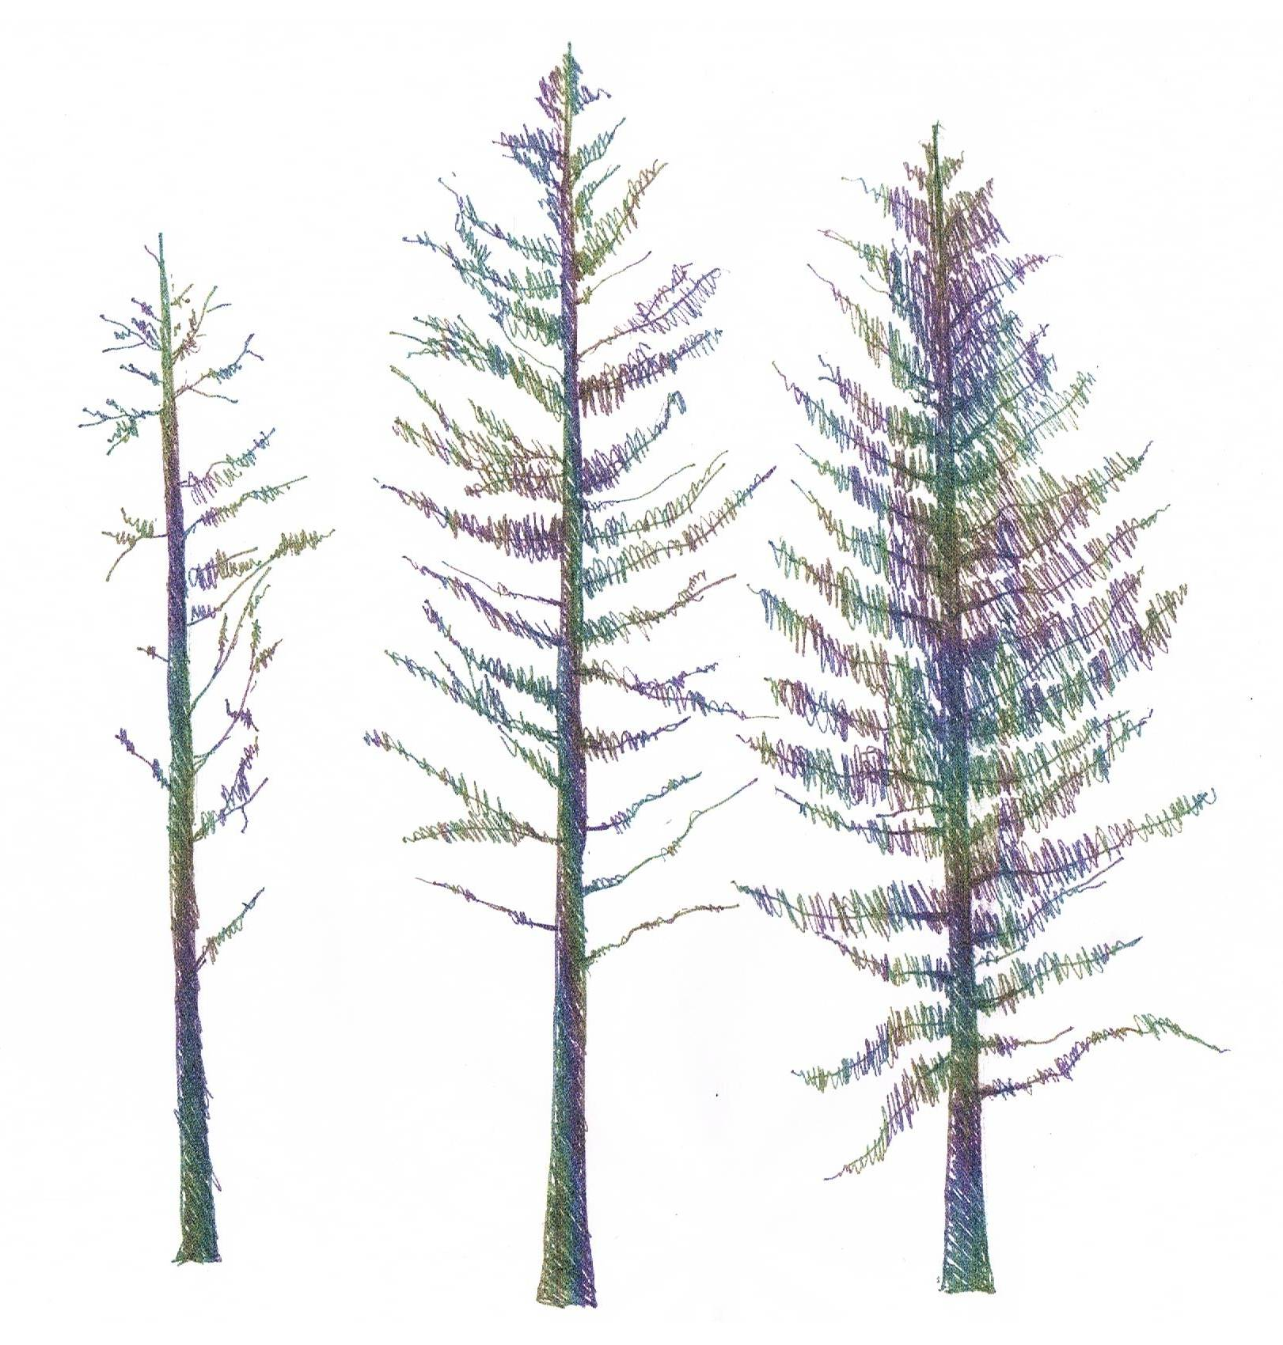
The three trees above show low, moderate, and high leaf density, left to right.

Illustrations of leaf density and color:

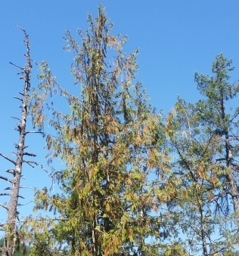 | Left: Cedar showing low leaf density at top (=1), moderate leaf density in middle and bottom (score = 2). Shows green to brown coloration for the entire tree (score = 2 for each level of tree).

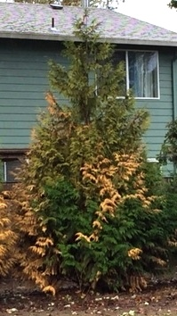 | 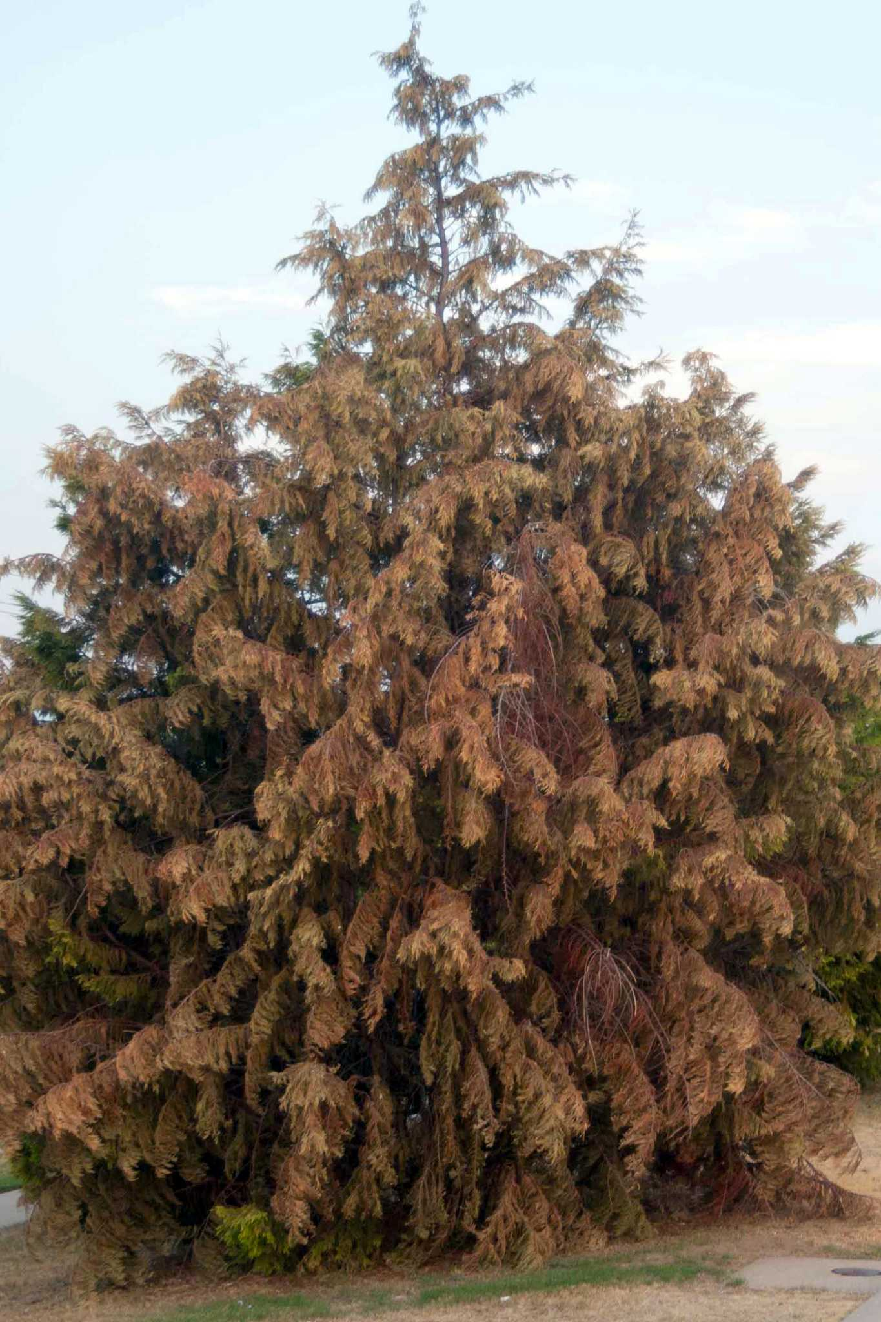
Above: Moderate leaf density for top (score = 2), high leaf density for middle and bottom (score = 3). Top color = 3, middle color = 2, bottom color is mixed, average score = 2 (note the mixture of dark green and obvious brown coloration in the comments section) | Above: leaf density is moderate for the top (score = 2); high density for middle and bottom (score = 3). Leaf coloration = 2 at all three levels, close to being a 1, but there appears to be some color still.

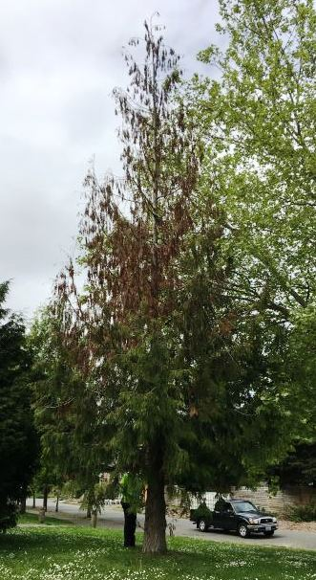
Above: leaf density at top = 1, at middle = 2, at bottom = 3. Leaf color = 1 at top, 1in middle, 2 or 3 at the bottom (hard to see details in this picture, might be a 2 for bottom).

Frequently Asked Questions:

- How do you rate a tree that only has branches on one side, but is otherwise healthy? Generally, the reason for this condition is because the other sides of the tree do not have good access to sunlight. Rate the portions of the tree with this condition based on what foliage is present. A tree with good foliage density and good color on the bottom third should be rated 3’s for both categories.
- How do you count dead trees?
If this is the first time a trail is being monitored, the dead tree do not need to be counted (since the monitoring program trying to assess the ongoing health of the cedars). If a tree dies, keep the tree on the data sheet and note 0’s for the density and color. If the tree eventually breaks off, so that it is less than 1-1/2 meters, note the change in the comments section of the data sheet. If there is no foliage left, put in zeros for the foliage characterization. If no foliage is present on the next survey, list the tree as dead.
ATTACHMENT 1

CEDAR SURVEY DATA SHEET 2023-04-24rev |  |  |  |  |  |  |  |  |  | Tree Height: |  | 1 = 2 – 10 meters; 2 = 10 – 20 meters; 3 = > 20 meters (approximate)
Trail: |  |  | Direction of travel: |  |  |  |  |  |  | Tree Leaf Density: |  | 3 = dense; 2 = moderate 1 = sparse 0 = bare
Date: |  |  | Monitors: |  |  |  |  |  |  | Tree Leaf Color: |  | 3 = green; 2 = faded green; 1 = brown
Tree # | Side of Trail | Distance meters | Height (1-3) | Trees < 2m Count |  | Top Third |  | Middle Third |  | Bottom Third |  | Dead? | Comments
 |  |  |  | Left Side Count | Right Side Count | Density (0-3) | Color (1-3) | Density (0-3) | Color (1-3) | Density (0-3) | Color (1-3) | If Dead Enter: yes | Comments | Tree Leaf Density Average | Tree Leaf Color Average
1 |  |  |  |  |  |  |  |  |  |  |  |  |  | 0.0 | 0.0
2 |  |  |  |  |  |  |  |  |  |  |  |  |  | 0.0 | 0.0
3 |  |  |  |  |  |  |  |  |  |  |  |  |  | 0.0 | 0.0
4 |  |  |  |  |  |  |  |  |  |  |  |  |  | 0.0 | 0.0
5 |  |  |  |  |  |  |  |  |  |  |  |  |  | 0.0 | 0.0
6 |  |  |  |  |  |  |  |  |  |  |  |  |  | 0.0 | 0.0
7 |  |  |  |  |  |  |  |  |  |  |  |  |  | 0.0 | 0.0
8 |  |  |  |  |  |  |  |  |  |  |  |  |  | 0.0 | 0.0
9 |  |  |  |  |  |  |  |  |  |  |  |  |  | 0.0 | 0.0
10 |  |  |  |  |  |  |  |  |  |  |  |  |  | 0.0 | 0.0
11 |  |  |  |  |  |  |  |  |  |  |  |  |  | 0.0 | 0.0
12 |  |  |  |  |  |  |  |  |  |  |  |  |  | 0.0 | 0.0
13 |  |  |  |  |  |  |  |  |  |  |  |  |  | 0.0 | 0.0
14 |  |  |  |  |  |  |  |  |  |  |  |  |  | 0.0 | 0.0
15 |  |  |  |  |  |  |  |  |  |  |  |  |  | 0.0 | 0.0
16 |  |  |  |  |  |  |  |  |  |  |  |  |  | 0.0 | 0.0
17 |  |  |  |  |  |  |  |  |  |  |  |  |  | 0.0 | 0.0
18 |  |  |  |  |  |  |  |  |  |  |  |  |  | 0.0 | 0.0
19 |  |  |  |  |  |  |  |  |  |  |  |  |  | 0.0 | 0.0
20 |  |  |  |  |  |  |  |  |  |  |  |  |  | 0.0 | 0.0
21 |  |  |  |  |  |  |  |  |  |  |  |  |  | 0.0 | 0.0
22 |  |  |  |  |  |  |  |  |  |  |  |  |  | 0.0 | 0.0
23 |  |  |  |  |  |  |  |  |  |  |  |  |  | 0.0 | 0.0
24 |  |  |  |  |  |  |  |  |  |  |  |  |  | 0.0 | 0.0
25 |  |  |  |  |  |  |  |  |  |  |  |  |  | 0.0 | 0.0
26 |  |  |  |  |  |  |  |  |  |  |  |  |  | 0.0 | 0.0
27 |  |  |  |  |  |  |  |  |  |  |  |  |  | 0.0 | 0.0
28 |  |  |  |  |  |  |  |  |  |  |  |  |  | 0.0 | 0.0
29 |  |  |  |  |  |  |  |  |  |  |  |  |  | 0.0 | 0.0
30 |  |  |  |  |  |  |  |  |  |  |  |  |  | 0.0 | 0.0
31 |  |  |  |  |  |  |  |  |  |  |  |  |  | 0.0 | 0.0
32 |  |  |  |  |  |  |  |  |  |  |  |  |  | 0.0 | 0.0
33 |  |  |  |  |  |  |  |  |  |  |  |  |  | 0.0 | 0.0
34 |  |  |  |  |  |  |  |  |  |  |  |  |  | 0.0 | 0.0
35 |  |  |  |  |  |  |  |  |  |  |  |  |  | 0.0 | 0.0
36 |  |  |  |  |  |  |  |  |  |  |  |  |  | 0.0 | 0.0
37 |  |  |  |  |  |  |  |  |  |  |  |  |  | 0.0 | 0.0
38 |  |  |  |  |  |  |  |  |  |  |  |  |  | 0.0 | 0.0
39 |  |  |  |  |  |  |  |  |  |  |  |  |  | 0.0 | 0.0
40 |  |  |  |  |  |  |  |  |  |  |  |  |  | 0.0 | 0.0
41 |  |  |  |  |  |  |  |  |  |  |  |  |  | 0.0 | 0.0
42 |  |  |  |  |  |  |  |  |  |  |  |  |  | 0.0 | 0.0
43 |  |  |  |  |  |  |  |  |  |  |  |  |  | 0.0 | 0.0
44 |  |  |  |  |  |  |  |  |  |  |  |  |  | 0.0 | 0.0
45 |  |  |  |  |  |  |  |  |  |  |  |  |  | 0.0 | 0.0
46 |  |  |  |  |  |  |  |  |  |  |  |  |  | 0.0 | 0.0
47 |  |  |  |  |  |  |  |  |  |  |  |  |  | 0.0 | 0.0
48 |  |  |  |  |  |  |  |  |  |  |  |  |  | 0.0 | 0.0
49 |  |  |  |  |  |  |  |  |  |  |  |  |  | 0.0 | 0.0
50 |  |  |  |  |  |  |  |  |  |  |  |  |  | 0.0 | 0.0
51 |  |  |  |  |  |  |  |  |  |  |  |  |  | 0.0 | 0.0
52 |  |  |  |  |  |  |  |  |  |  |  |  |  | 0.0 | 0.0
53 |  |  |  |  |  |  |  |  |  |  |  |  |  | 0.0 | 0.0
54 |  |  |  |  |  |  |  |  |  |  |  |  |  | 0.0 | 0.0
55 |  |  |  |  |  |  |  |  |  |  |  |  |  | 0.0 | 0.0
56 |  |  |  |  |  |  |  |  |  |  |  |  |  | 0.0 | 0.0
57 |  |  |  |  |  |  |  |  |  |  |  |  |  | 0.0 | 0.0
58 |  |  |  |  |  |  |  |  |  |  |  |  |  | 0.0 | 0.0
59 |  |  |  |  |  |  |  |  |  |  |  |  |  | 0.0 | 0.0
60 |  |  |  |  |  |  |  |  |  |  |  |  |  | 0.0 | 0.0
61 |  |  |  |  |  |  |  |  |  |  |  |  |  | 0.0 | 0.0
62 |  |  |  |  |  |  |  |  |  |  |  |  |  | 0.0 | 0.0
63 |  |  |  |  |  |  |  |  |  |  |  |  |  | 0.0 | 0.0
64 |  |  |  |  |  |  |  |  |  |  |  |  |  | 0.0 | 0.0
65 |  |  |  |  |  |  |  |  |  |  |  |  |  | 0.0 | 0.0
66 |  |  |  |  |  |  |  |  |  |  |  |  |  | 0.0 | 0.0
67 |  |  |  |  |  |  |  |  |  |  |  |  |  | 0.0 | 0.0
68 |  |  |  |  |  |  |  |  |  |  |  |  |  | 0.0 | 0.0
69 |  |  |  |  |  |  |  |  |  |  |  |  |  | 0.0 | 0.0
70 |  |  |  |  |  |  |  |  |  |  |  |  |  | 0.0 | 0.0
71 |  |  |  |  |  |  |  |  |  |  |  |  |  | 0.0 | 0.0
72 |  |  |  |  |  |  |  |  |  |  |  |  |  | 0.0 | 0.0
73 |  |  |  |  |  |  |  |  |  |  |  |  |  | 0.0 | 0.0
74 |  |  |  |  |  |  |  |  |  |  |  |  |  | 0.0 | 0.0
75 |  |  |  |  |  |  |  |  |  |  |  |  |  | 0.0 | 0.0
76 |  |  |  |  |  |  |  |  |  |  |  |  |  | 0.0 | 0.0
77 |  |  |  |  |  |  |  |  |  |  |  |  |  | 0.0 | 0.0
78 |  |  |  |  |  |  |  |  |  |  |  |  |  | 0.0 | 0.0
79 |  |  |  |  |  |  |  |  |  |  |  |  |  | 0.0 | 0.0
80 |  |  |  |  |  |  |  |  |  |  |  |  |  | 0.0 | 0.0
81 |  |  |  |  |  |  |  |  |  |  |  |  |  | 0.0 | 0.0
82 |  |  |  |  |  |  |  |  |  |  |  |  |  | 0.0 | 0.0
83 |  |  |  |  |  |  |  |  |  |  |  |  |  | 0.0 | 0.0
84 |  |  |  |  |  |  |  |  |  |  |  |  |  | 0.0 | 0.0
85 |  |  |  |  |  |  |  |  |  |  |  |  |  | 0.0 | 0.0
86 |  |  |  |  |  |  |  |  |  |  |  |  |  | 0.0 | 0.0
87 |  |  |  |  |  |  |  |  |  |  |  |  |  | 0.0 | 0.0
88 |  |  |  |  |  |  |  |  |  |  |  |  |  | 0.0 | 0.0
89 |  |  |  |  |  |  |  |  |  |  |  |  |  | 0.0 | 0.0
90 |  |  |  |  |  |  |  |  |  |  |  |  |  | 0.0 | 0.0
91 |  |  |  |  |  |  |  |  |  |  |  |  |  | 0.0 | 0.0
92 |  |  |  |  |  |  |  |  |  |  |  |  |  | 0.0 | 0.0
93 |  |  |  |  |  |  |  |  |  |  |  |  |  | 0.0 | 0.0
94 |  |  |  |  |  |  |  |  |  |  |  |  |  | 0.0 | 0.0
95 |  |  |  |  |  |  |  |  |  |  |  |  |  | 0.0 | 0.0
96 |  |  |  |  |  |  |  |  |  |  |  |  |  | 0.0 | 0.0
97 |  |  |  |  |  |  |  |  |  |  |  |  |  | 0.0 | 0.0
98 |  |  |  |  |  |  |  |  |  |  |  |  |  | 0.0 | 0.0
99 |  |  |  |  |  |  |  |  |  |  |  |  |  | 0.0 | 0.0
100 |  |  |  |  |  |  |  |  |  |  |  |  |  | 0.0 | 0.0

