Forest Phenology Guide

Background
Phenology is the study of cyclic and seasonal natural phenomena, especially in relation to climate and plant life. Plant characteristics vary from year to year, based on weather-related phenomena such as temperature, precipitation, and soil moisture. Several characteristics (e.g., bud break, leaf expansion, flowering, leaf fall) can be readily observed and recorded, with long-term data providing insight on the potential effects of interannual variation in weather and multi-decadal variation in climate.

Phenological monitoring will focus on dominant tree species and perhaps other plants. The data will be collected and archived over decades, and will be shared online with the public and possibly with the National Phenology Network. It is anticipated that these data will provide insight on the effects of long-term climatic variability and change, as well as engage local communities in understanding how climate affects forest structure and function.

Methods
Data will be collected on 3 individuals of each target species. Trees will ideally be codominant without any apparent damage from major injury, fungi, or insects. They will be on a gentle side slope, not on a prominent convexity or concavity or near an obvious water source. Branches should be easily viewable from the ground. Plants will be marked with tags, so the same trees can be revisited for subsequent monitoring. Three branches will be measured on each plant.

Bud break of leaves and flowers is a particularly important phenological characteristic. Buds have protective scales that cover the embryonic leaves of growing (meristematic) areas during a resting (dormant) phase, will swell, signaling renewed metabolic activity. The tight covering of bud scales over the embryonic leaves (or flowers) will loosen and expand—the bud appears to be swelling—gradually separating open so that the newly growing leaves (or flowers) can be seen at the bud tip. Bud break is considered the point at which newly growing leaves are exposed between the scales of the bud.

The following phenological characteristics will be recorded:
- Leaf bud break
- Full leaf emergence
- Full leaf expansion
- First significant autumn coloration in leaves (hardwoods)
- Initial leaf senescence (hardwoods)
- All leaves senesced (hardwoods)
- Flower bud break (hardwoods and understory)

Photo guides will be used as a reference for observers. Having the same person or group measuring the same characteristics from year to year would be ideal, although training and calibration of different people can help ensure consistency. It is imperative that sample trees be visited frequently (every 2-3 days) during times of the year when phenological changes typically occur.

Photographs should be taken at each phenological point when it is observed: first bud break, full leaf emergence, full leaf expansion, flower bud break, etc. This will help ensure consistency, be useful for training, and serve as additional documentation of what is observed. Use a camera that can focus on the necessary details. Even most camera phones can now do this; do not use the zoom feature unless it is an optical zoom. Most phones are digital zooms, which degrade the picture quality.

Coniferous trees — Leaf buds
For each sample branch, focus on the first leaf bud to open, then use that bud for all subsequent leaf observations. Bud break occurs when the bud scales are pushed back from the tip, and you can see the immature leaves uncovered by the bud scales.

Additional leaf observations:
- Leaf emergence is the point after bud break at which you can see individual entire leaves, as opposed to leaves folded in the bud.

Deciduous trees and shrubs — Leaf buds
For each sample branch, focus on the first leaf bud to open, then use that bud for all subsequent leaf observations. Bud break occurs when the bud scales are pushed back from the tip, and you can see the immature leaves uncovered by the bud scales. See photos for reference.

Additional leaf observations:
- Leaf emergence is the point after bud break at which you can see one entire leaf, as opposed to a leaf folded in the bud. Use the first leaf emerged for observations of leaf expansion. If multiple leaves emerge simultaneously, select one of the leaves for observations of leaf expansion.
- Leaf expansion is the point at which the first emergent leaf is fully expanded. This may take days to weeks, requiring long-term monitoring. Measure the leaf from base to tip as a way to track leaf growth over time and record the length over time; these measurements are not reported on the data sheet.

Deciduous trees and shrubs — Flower buds
For each sample branch, focus on the first flower bud to open. Bud break occurs when the bud scales are pushed back from the tip, and you can see the immature flower uncovered by the bud scales.

Phenological stages of conifers

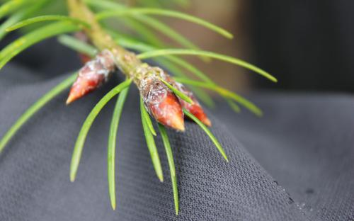 | Douglas-fir, dormant buds with bud scales covering primordial leaves.
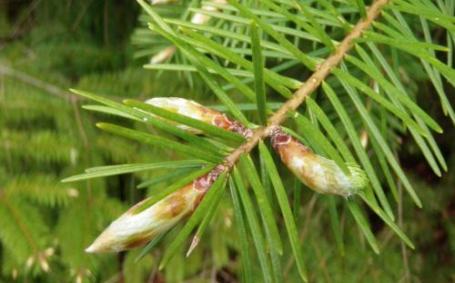 | Douglas-fir, bud break starting on bud on the right side where needles are emerging
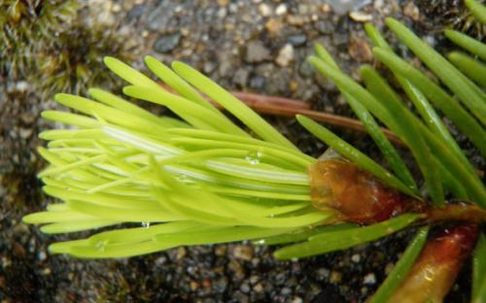 | Douglas-fir, needles emerged from bud
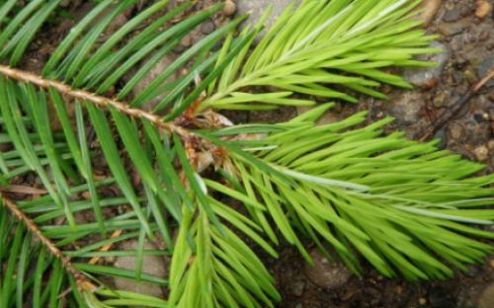 | Douglas-fir, needles expanded  (this is not recorded)

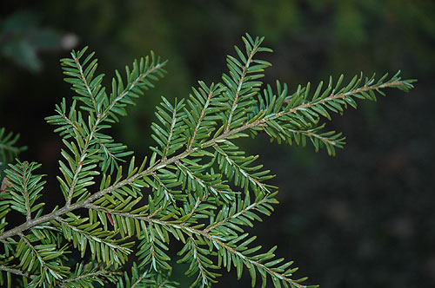 | Western hemlock, dormant buds with bud scales covering primordial leaves.
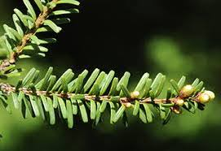  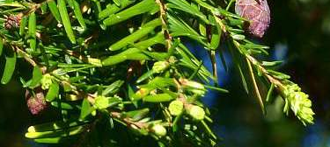 | Western hemlock, bud break
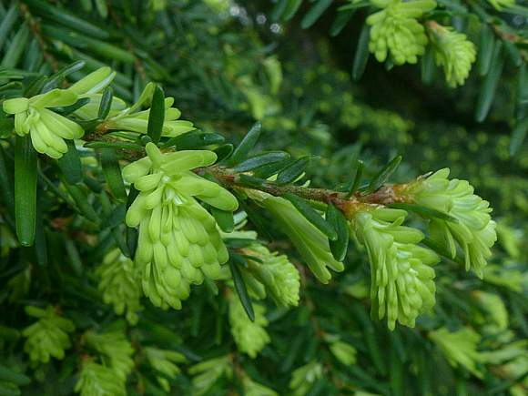 | Western hemlock, needles emerged
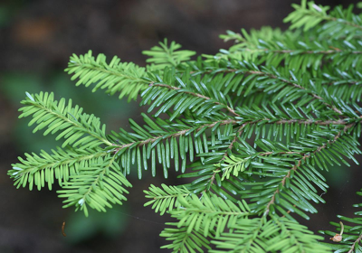 | Western hemlock, needles expanded  (this is not recorded)
Phenological stages of deciduous trees and shrubs

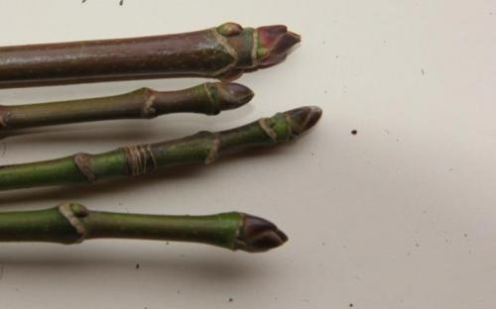 | Bigleaf maple, buds closed
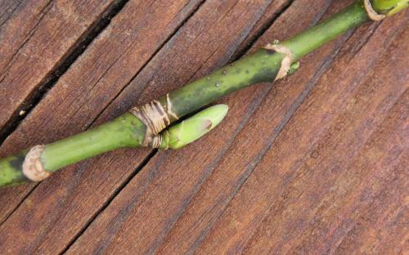 | Bigleaf maple, bud swelling
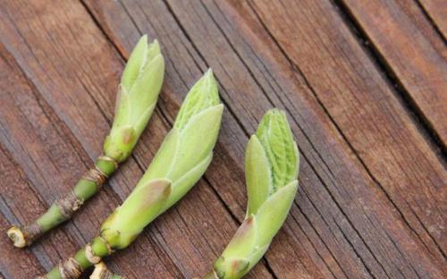 | Bigleaf maple, showing (left to right) bud nearly open, bud break, and leaves emerging from bud
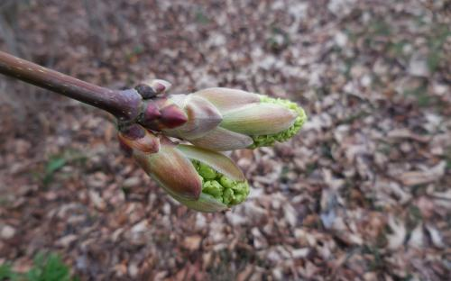 | Bigleaf maple, flower at bud break
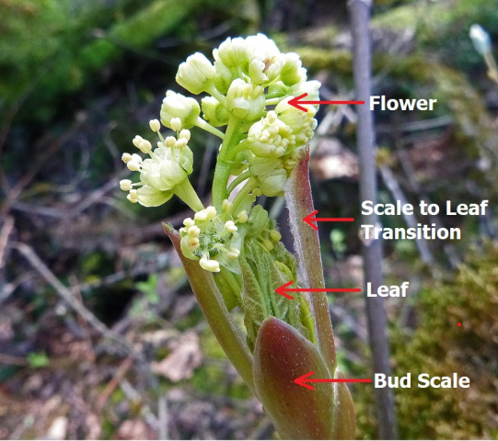 | Bigleaf maple, flower recently emerged
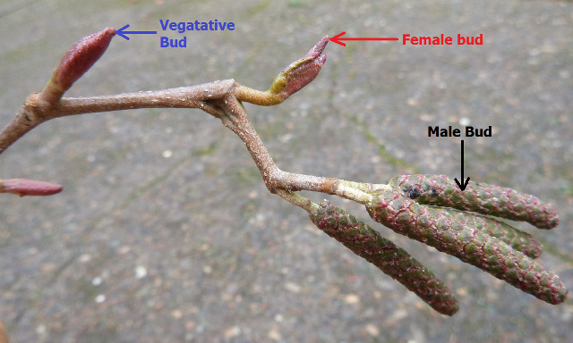  Female bud  Leaf bud  Male bud |  | Red alder, with leaf, female, and male buds
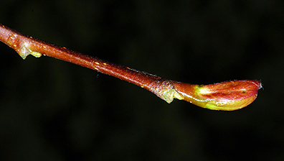 |  | Red alder, leaf bud break
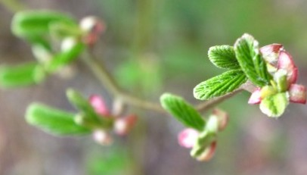 |  | Red alder, leaves just emerged

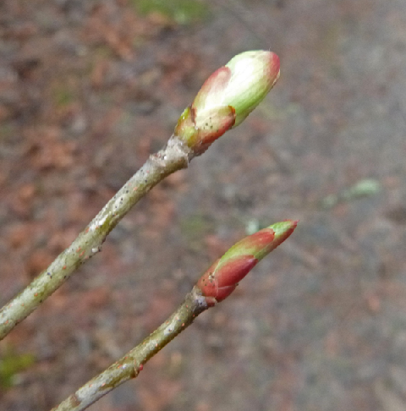 | Indian plum, upper bud contains leaves and flowers, lower bud contains only leaves
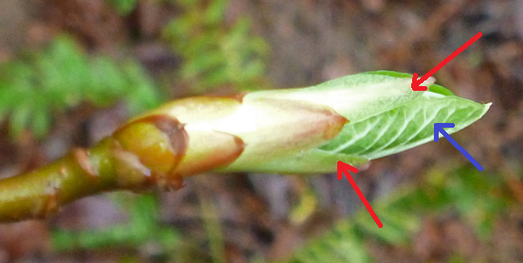 | Indian plum, leaves extending beyond bud scales just after bud break

